*[Read the question fully first]*

**ASP.NET Core MVC and ASP.NET Core WEB API**

**Ticket booking Problem**

Nancy is working in a popular paradise hall, which is the best event organizing, planning, coordinating and managing company in Mumbai. The Manager of the Popular Paradise hall decided to develop a web api for booking tickets for a stage show. He has given that work to Sarra. But she doesn't know how to develop a web api with a database connection. Help her to develop a ticket booking application.

Write an ASP.NET WEB API program for the ticket booking application which retrieves the ticket booking details and if ticket booked successfully then returns **Ticked Booked Successfully!!!.**and the ticket count should be updated and if the requested number of tickets not available returns **Requested number of tickets not available**.

Consider the class **SeatingSection**with the following attributes

|  |  |
| --- | --- |
| **Data Type** | **Attributes** |
| int | _id |
| string | _seatingType |
| double | _ticketCost |
| int | _numberOfTickets |

Use properties for **get**, **set** and method **constructors** as per need.  
  
Consider the class **SeatingSectionDAL** and define the below methods to handle all database related operations

|  |  |  |
| --- | --- | --- |
| **S.No** | **Method Name** | **Description** |
| 1 | public List<SeatingSection> GetAllSeatingSection() | This method will return a list of SeatingType objects. |
| 2 | public boolean BookTicket(int seatingType,int ticketCount) | This method will return true if ticket booked successfully. If number of tickets are not available it will return false. After booking, ticket it must be updated in the database. |

**Page Flow:**

1. Create **Home**page in ASP.NET Core MVC which displays the seating section details from WEB API and backend database and a **Book** button.



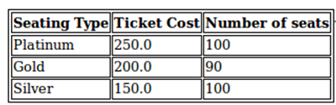



2. By clicking the **book** button, the request must display the page with show name, seating type, number of tickets as input and two buttons named **book** and **cancel**. (Seating type must be given in drop down box, keep option value for Platinum, Gold, Silver as 1, 2, 3 respectively).

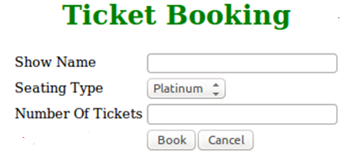

3. By clicking **cancel** button the request must be forwarded to the **Home Page**.

4. By clicking the **Book** button the request must be forwarded to **WEB API**. If the number of tickets is available, then update the ticket count and forward to **Home page** which displays the success message as provided in the screenshot. If tickets not available, then display the message accordingly.

